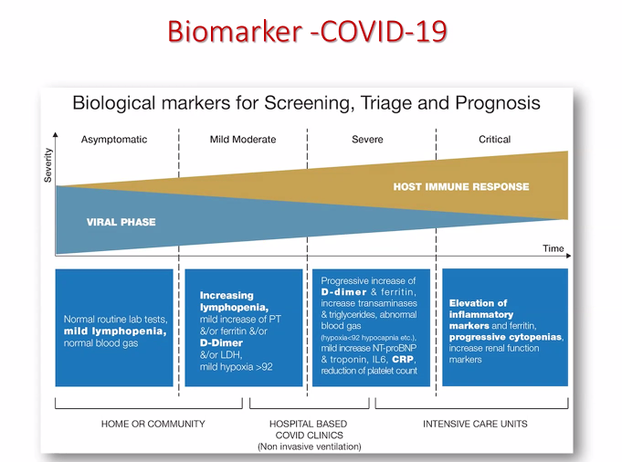

biological markers of a

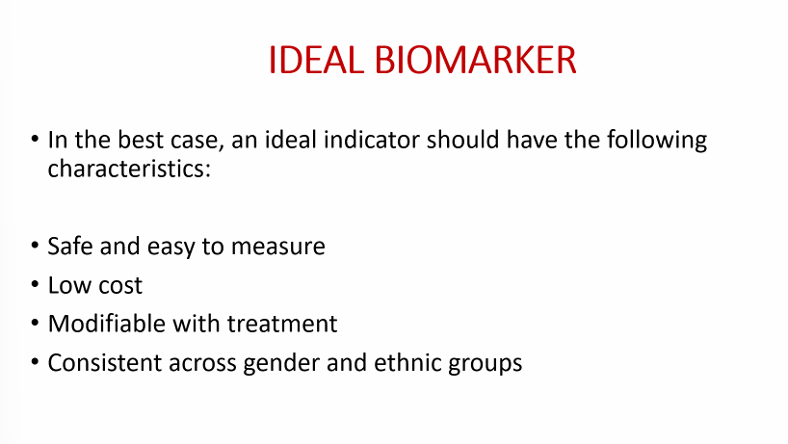
should have precise characteristic:
- must be safe and easy to measure ⟹ a blood sample it is easy and relatively safe.
- Another examion pretending to measure very specific biomarker it should have low cost
- You measure the ability of the treatment to solve the problem you are dealing with (pneumonia you use antibiotics and you see x-ray gets better or worst, in that case the biomarket gives you the idea that the treatment is working or not)
- Less important: with constant type of population but if you are generating a new biomarket is important, it should be consistent with gender and ethnic group, there might some changes given to ethnicity and gender

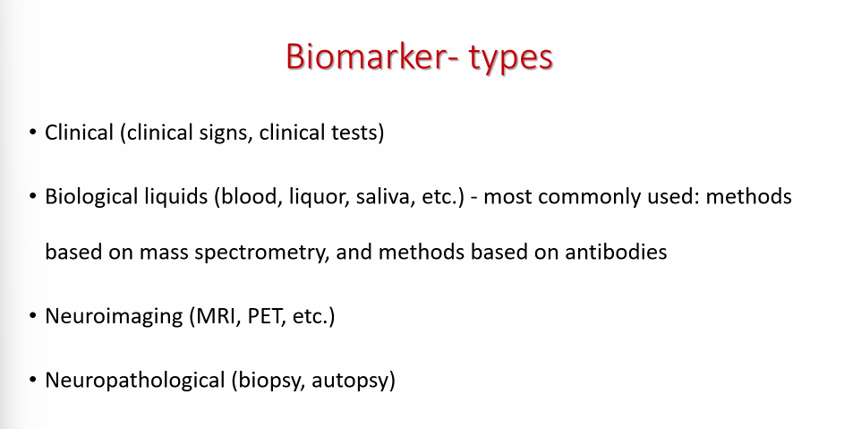
can have different types
can have clinical biomarkers, we made example of parkisonia patient, a tremor can be a biomarket (it is a clear sign)

We can have liquid (biological liquids), blood, liquor, saliva, … it is relatively easy

only specificalized people can utilize properly this biomakret and is not low cost

